**Verification Plan for EVR Application**

**JNDI changes for Security Hardcoded Password**

* Check - application is up & running.

As we have made the required changes for jndi in hibernate.xml and web.xml file in the EVR code. Now run the application at local space.

Login page will be visible for this app.

Now you can login and move forward with the verification of application.

Simultaneously capture the artifacts for proof.

* Artifacts:

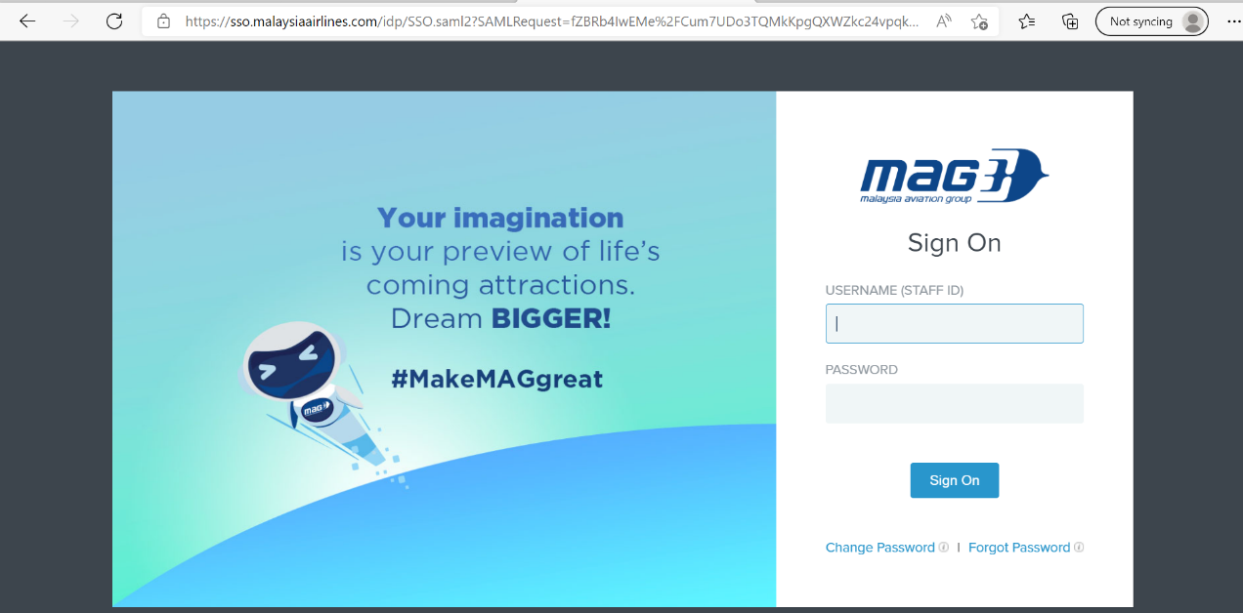

* Application Login is working fine.



* Released functionality./Basic functionality.
* Home page - after login is successful

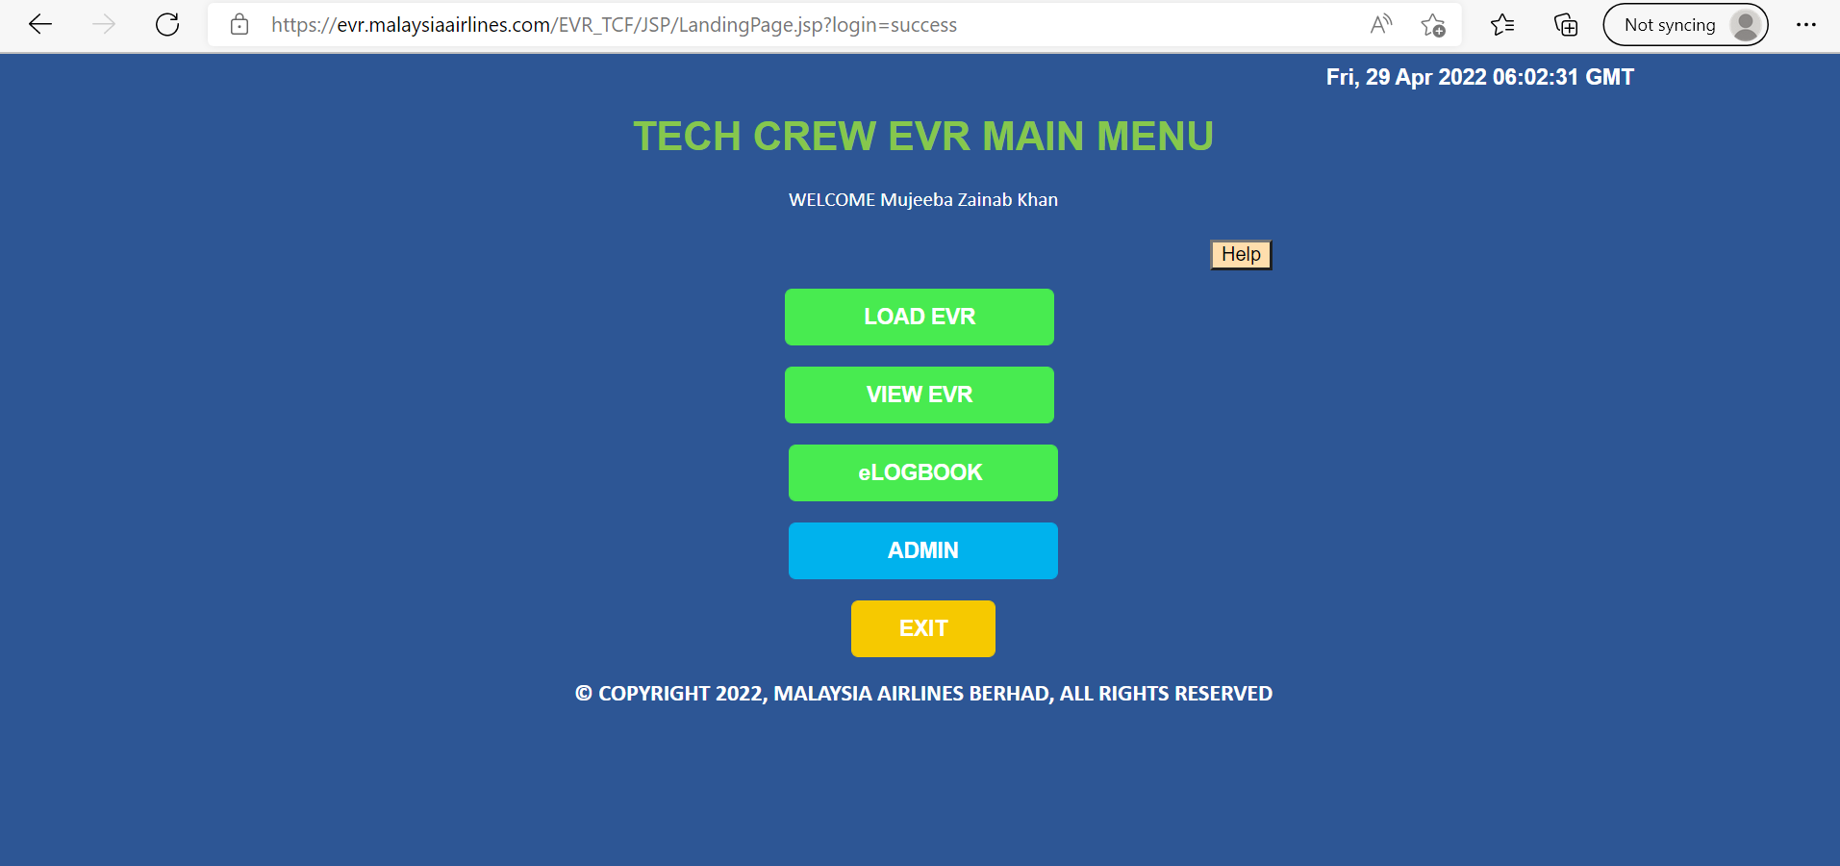

* Airline master page – under Low Maintenance header

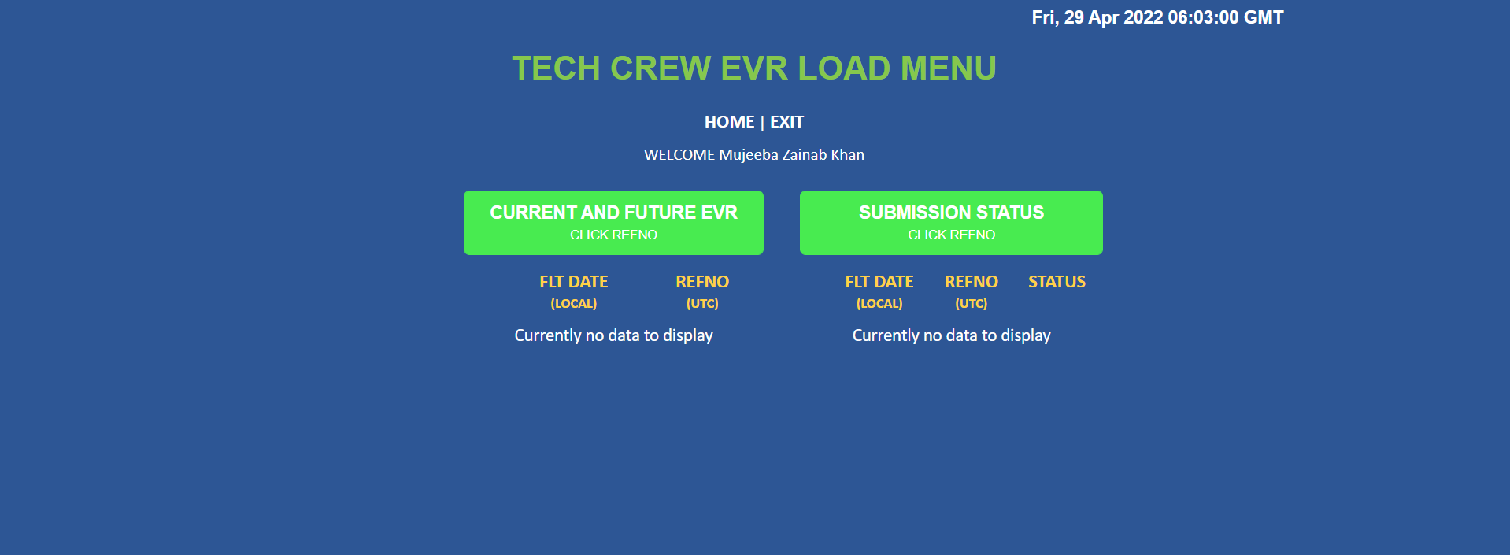

* Adhoc flights page – under High Maintenance header

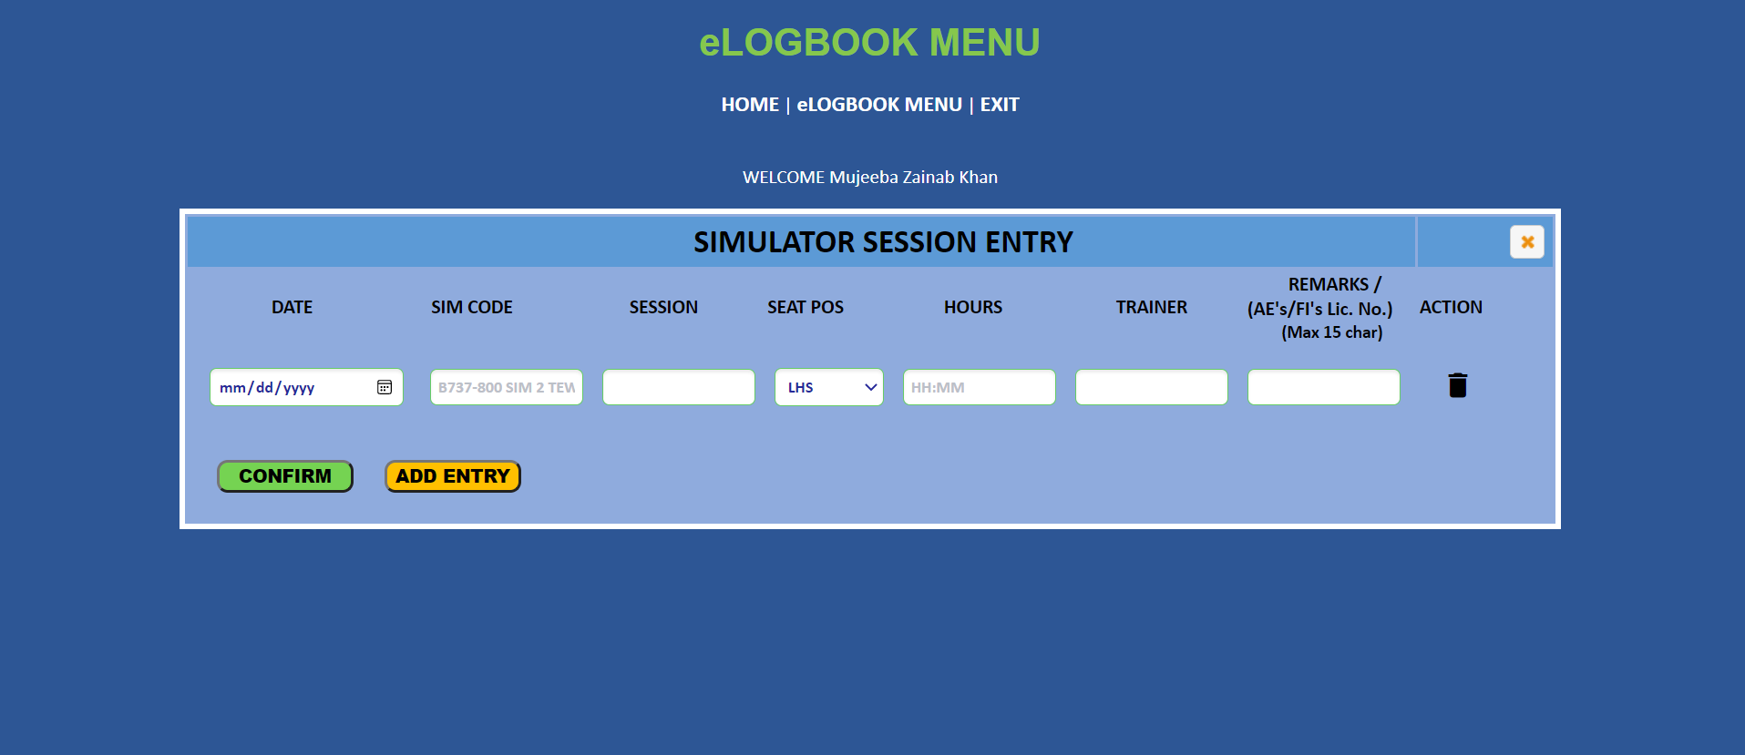

* User Management section

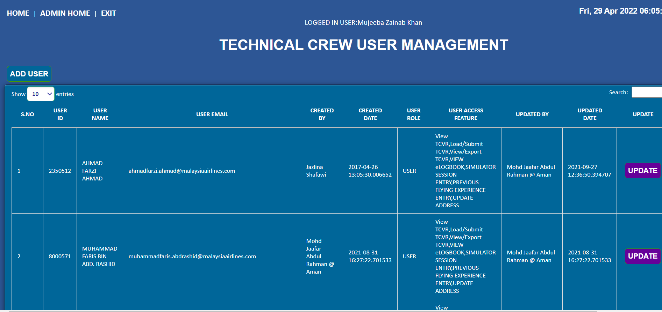

As we have validated the application and it is working fine, we can confirm the changes.